Reading List

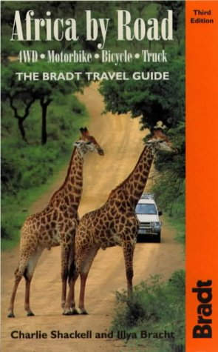 | Charlie Shackell and Ilya Bracht;  Bradt Publications  ISBN: 1841620173  £13.95 | Synopsis: This third edition brings travelers up to date on how to plan and get the most out of an overland trip. Detailed information on preparation backed up by on-the-road strategies, from driving through rivers to coping with bureaucracy. | Our verdict: Amongst the first of the books that we bought on the topic and a constant reference for checklists and necessary reminders!
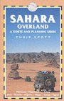 | Chris Scott;  Trailblazer Publications  ISBN: 1873756267  £19.99 | Synopsis: The Sahara Desert remains one of the world’s most fascinating and mysterious wildernesses. Looking beyond the romance of shimmering oases and magical dunes, this guide is a fully comprehensive handbook to understanding and exploring the world’s greatest desert. | Our verdict: Invaluable and informative with excellent detail. Some great pics to animate and inspire, also.
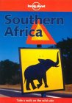 | Lonely Planet Publications  ISBN: 0864426623  £12.59 | Synopsis: This guide covers Botswana, Lesotho, Malawi, Mozambique, Namibia, South Africa, Swaziland, Zambia and Zimbabwe. It features a wildlife section, guide to the region's wildlife reserves and practical info on trekking, white-water rafting and canoeing. | Our verdict: Like with most LP books, this is a proven reference book and one we would not leave home – or Cape Town - without. Although this one is a bit old and there is now a 2003 edition available.
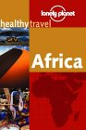 | Lonely Planet Publications  ISBN: 1864500506  £3.99 | Synopsis: This pocket-sized text is packed with answers to all the common health questions travellers ask. The book focuses on travelling in Africa. | Our verdict: Excellent prevention and treatment advice – will be an essential part of our first aid kit!
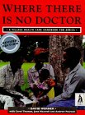 | Macmillan Education Ltd  ISBN: 0333516524  £8.10 | Synopsis: Printed in over 50 languages, this is the most widely used health care manual in developing countries today. It provides info about recognising, treating and preventing common illnesses and injuries. The African edition covers diseases commonly found in Africa. | Our verdict: Recommended by a nurse friend of ours working in Tanzania so it must be good! Another one for the first aid kit!
GUIDE BOOKS
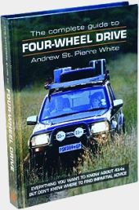 | Andrew St Pierre White;  International Motoring Productions  ISBN: 0620241845  £ 15.00 | Synopsis: This guide to four-wheel driving in Southern Africa is aimed at all 4x4 drivers, novice or experienced. The comprehensive info gives four-wheel drive motorists all the down-to-earth facts and tips they will need – buying, equipment, driving, recovery, repair, navigation and more. | Our verdict: Another essential read for us as relative newcomers to long-distance African travel and 4x4. He provides a good deal of detail, explanations and practical advice, often from his own or others’ real experiences.
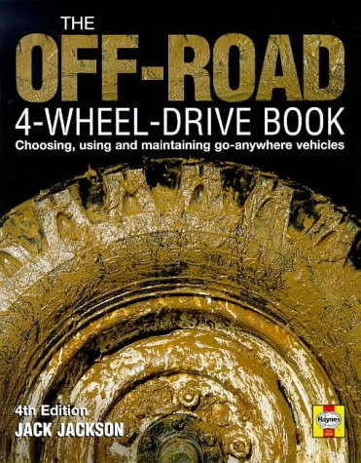 | Jack Jackson;  Haynes Group  ISBN:  1859606067  £13.99 | Synopsis: With 30 years experience of four-wheel drive expeditions to all parts of the world, Jackson gives details on driving in and recovering from hostile environments; advice on planning expeditions, with survival techniques, common problems and emergency field repairs; useful equipment, and information on engines, brakes, tyres and suspension. | Our verdict: More info on different terrains than above and excellent survival tips.

AFRICA GENERAL

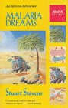 | Stuart Stevens;  Abacus  ISBN: 0349102112  £6.99 | Synopsis: The tale of the author's travels from the Central African Republic to Algiers as a favour for a friend, where he discovers that half of Africa thinks his friend is a spy and the other half is convinced he is a diamond smuggler. | Kate’s verdict: Slow to begin with but it gets there in the end, just as literally its author managed to from Chad to the UK! An enjoyable read, funny in parts and some useful tips for overland travel.
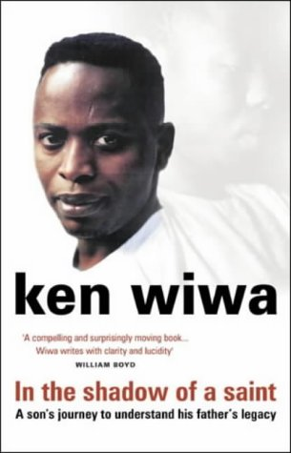 | Ken Wiwa;  Doubleday  ISBN: 0385601859  £6.39 | Synopsis: Ken Saro-Wiwa was executed in 1995. One of Nigeria's best-loved writers and critics of military rule, he was a mover in bringing the human rights abuses of Shell Oil and the Nigerian military to the world's attention. This work tells of Wiwa's childhood and relationship with his father. | Gareth’s verdict: A very worthwhile read, definitely. It provides a window into the tumultuous lives of Nigerians striving for some justice and peace in their own country through the lives of two very determined but different men – a father and a son.
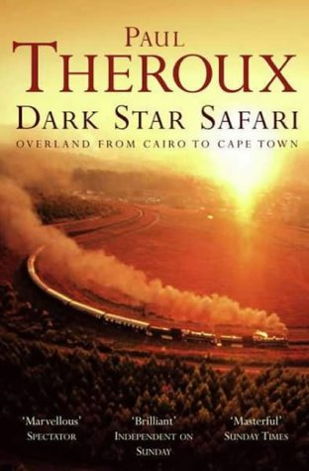 | Paul Theroux;  Penguin Books Ltd  ISBN: 0140281118  £3.99 | Synopsis: Embarking on another ambitious safari, Theroux journeys from Cairo to Cape Town by train, boat and cattle truck. He sets out to travel the length of Africa - and see everything in between - through some of the most beautiful and ravaged landscapes on earth. | Kate’s verdict: Not such an easy read and a bit of a negative outlook on Africa but didn’t actually finish and others say it’s good in the end.
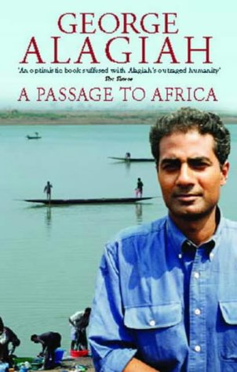 | George Alagiah;  Time Warner Paperbacks  ISBN: 0751532142  £6.39 | Synopsis: As a five-year-old, George Alagiah emigrated with his family to Ghana - the first African country to attain independence from the British Empire. This is Alagiah's shattering catalogue of atrocities, crafted into a portrait of Africa that is infused with hope, insight and outrage. | Our verdict: A great read. He writes with an understanding of African politics, culture, family and social life from personal experience giving superb insight to the reader.
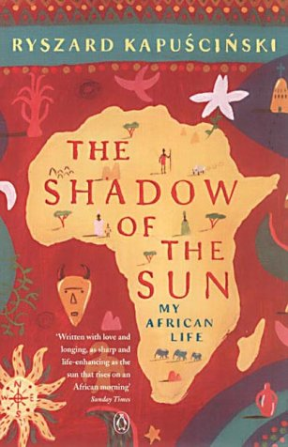 | Ryszard Kapuzcinski;  Penguin Books Ltd  ISBN: 0140292624  £7.19 | Synopsis: “In reality, except as a geographical term, Africa doesn't exist”. Kapuzcinski has been visiting Africa since 1957. Here he attempts to hold up a mirror to the ever-changing situations and predicaments of an entire continent. | Our verdict: Quite simply, a great read. A contemporary classic on Africa through the last 30 years. Given to me by a friend who came to visit in Zanzibar, I have now recommended it to almost everyone I have ever had an ‘African chat’ with!
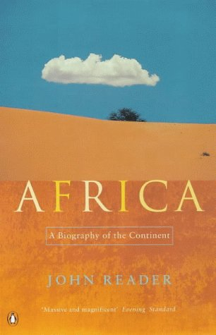 | John Reader;  Penguin Books Ltd  ISBN: 0140266755  £11.19 | Synopsis: “The roots of our ancestry lie in Africa”. John Reader’s brilliant, panoramic survey traces the development of this huge continent from its earliest geological formation and the beginnings of life, through to the civil wars and genocide that mark it today. | Gareth’s verdict: The most important book I have read on Africa so far and may ever read! Essential for anyone who wishes to try to understand any part of the continent. Hard-going in the opening chapters with lots of terminology. However, perseverance is much-rewarded.
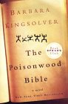 | Barbara Kingsolver;  HarperCollins  ISBN: 0060930535  £3.99 | Synopsis: A story told by the wife and four daughters of Nathan Price, a fierce evangelical Baptist who takes his family and mission to the Belgian Congo in 1959, where they find their lives transformed over the course of three decades. | Kate’s verdict: An excellent read, highly emotive story and a good way to learn about some of the history of the Congo through the lives of the family.
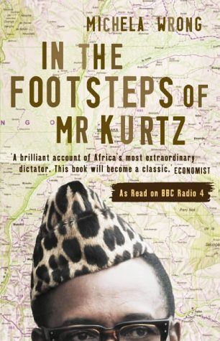 | Michela Wrong  Fourth Estate Ltd  ISBN: 1841154229  £6.39 | Synopsis: A sparkling account of the rise and fall of Mobutu Sese Seko, the charismatic dictator who plundered his country’s wealth and indulged a passion for pink champagne, gold jewellery and chartered Concordes. Absurdity, anarchy and corruption run riot in this fascinating dissection of the Congo. | Gareth’s verdict: A very easy read, with highly entertaining stories of one of the most outrageous of modern African dictators. One of the abiding memories from this book is just how ordinary people manage to survive with their dignity and sense of humour still intact.
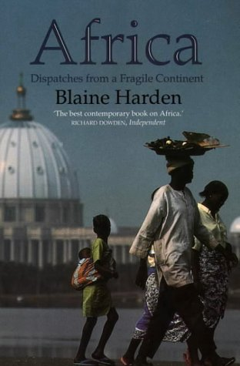 | Blaine Harden;  Flamingo  ISBN: 0006378560  £6.99 | Synopsis: A distinguished American reporter, Harden reveals the true and often unsightly picture of Africa. He addresses issues such as the incompetent intervention of Western governments and the battle between the tribal way of life and modernity through stories about individual people and incidents he has known. | Kate’s verdict: Very easy to read but also very disturbing. It is controversial and really makes you think about where Africa is going and what it is becoming.
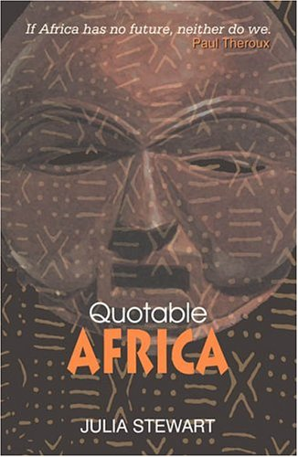 | Julia Stewart;  Penguin Global  ISBN: 0143024574  £14.86 | Synopsis: Stewart’s book covers the whole of Africa – north to south and east to west – and includes memorable statements from hundreds of speakers including Nelson Mandela, Chinua Achebe, Kofi Annan, as well as biblical passages and proverbs. | Gareth’s verdict: Hard to put down every time I delve into any page, the quotes are well-chosen from a wide range of topics and nationalities. Thought-provoking, funny and enlightening.
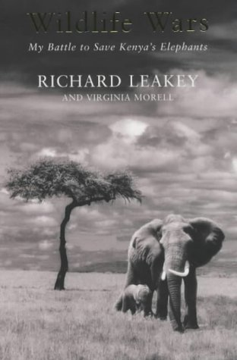 | Wildlife Wars;  Richard Leakey;  Pan  ISBN: 0330372408  £6.39 | Synopsis: In 1989, Kenyan president Daniel arap Moi put Richard Leakey in charge of the Kenyan Wildlife Service. Ivory poachers were killing hundreds of elephants annually and the organisation was close to collapse. Leakey's clashes with poachers and the dictator Moi provide a dramatic focus for the book. | Gareth’s verdict: As controversial a figure as he is, you cannot help but respect and admire Leakey’s achievements. His story is crucial to the survival of Africa’s wild heritage and one which should be read more than once.

